**fminunc**

Find minimum of unconstrained multivariable function

**Syntax**

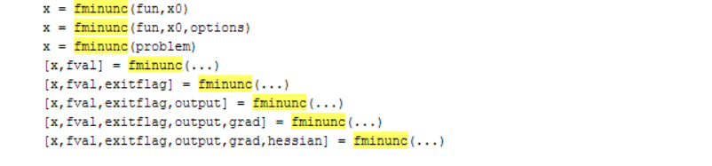

**Description**

fminunc attempts to find a minimum of a scalar function of several variables, starting at an initial estimate. This is generally referred to as unconstrained nonlinear optimization.

x = fminunc(fun,x0) starts at the point x0 and attempts to find a local minimum x of the function described in fun. x0 can be a scalar, vector, or matrix.

x = fminunc(fun,x0,options) minimizes with the optimization options specified in options. Use optimoptions to set these options.

x = fminunc(problem) finds the minimum for problem, where problem is a structure described in Input Arguments.

Create the problem structure by exporting a problem from Optimization app, as described in Exporting Your Work.

[x,fval] = fminunc(...) returns in fval the value of the objective function fun at the solution x.

[x,fval,exitflag] = fminunc(...) returns a value exitflag that describes the exit condition.

[x,fval,exitflag,output] = fminunc(...) returns a structure output that contains information about the optimization.

[x,fval,exitflag,output,grad] = fminunc(...) returns in grad the value of the gradient of fun at the solution x.

[x,fval,exitflag,output,grad,hessian] = fminunc(...) returns in hessian the value of the Hessian of the objective function fun at the solution x. See Hessian.

**Examples**

